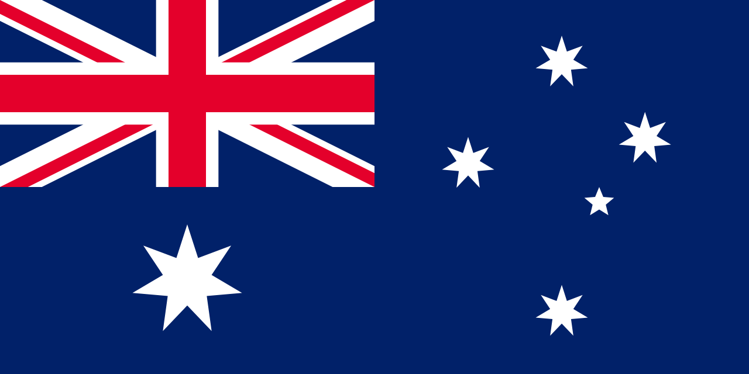
AUSTRALIA

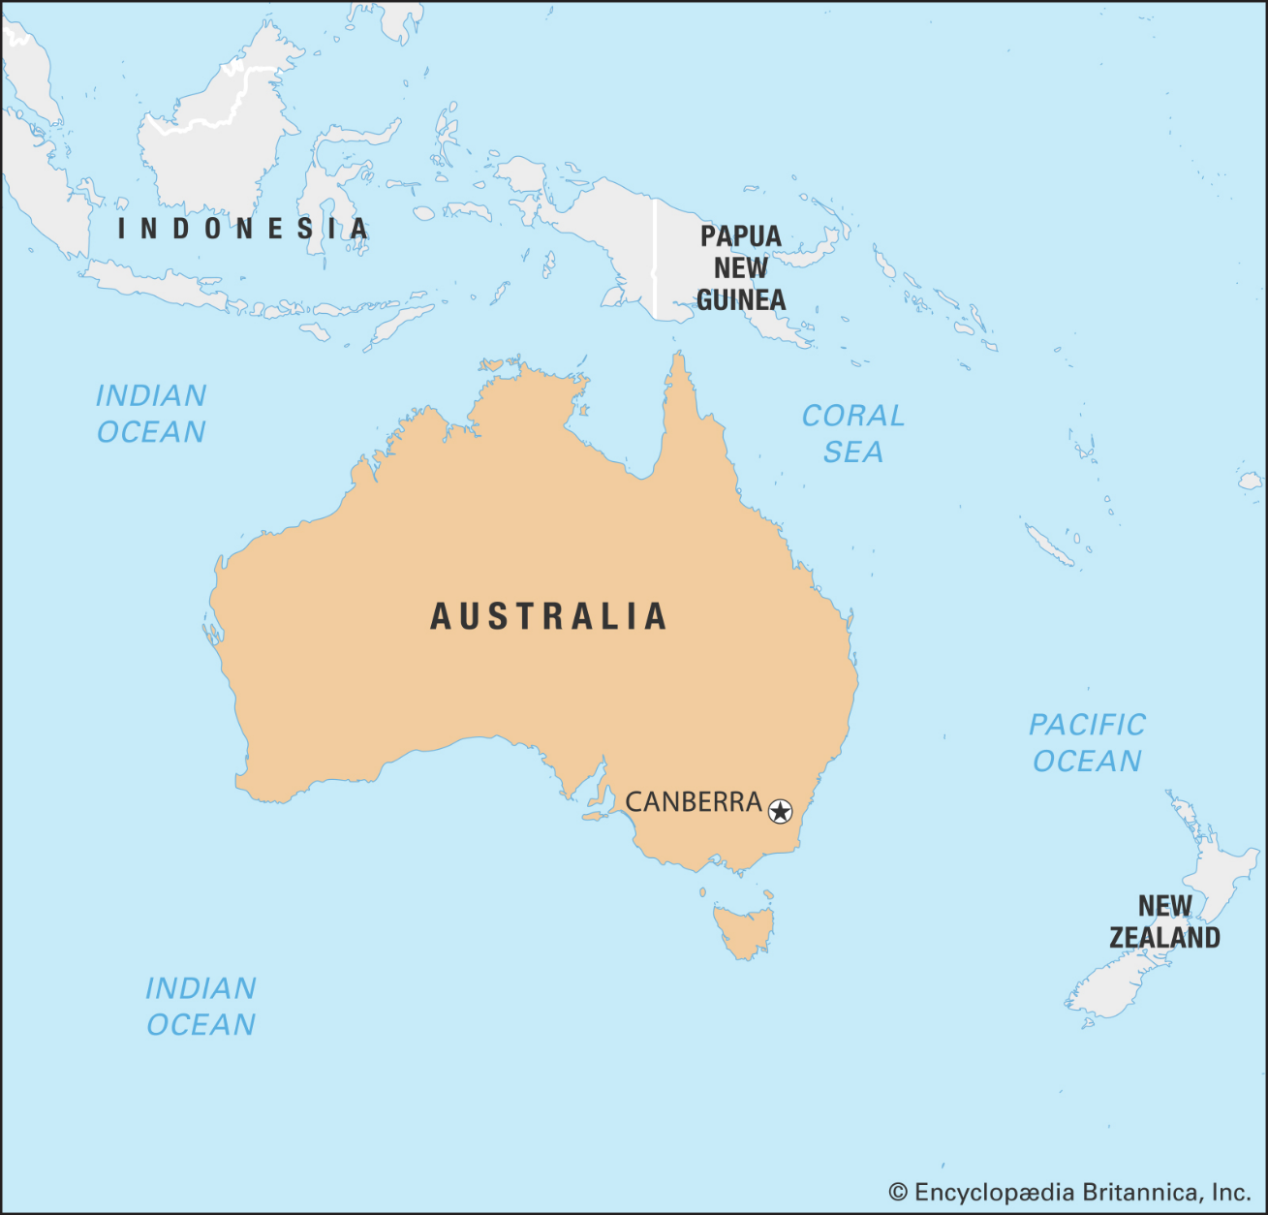
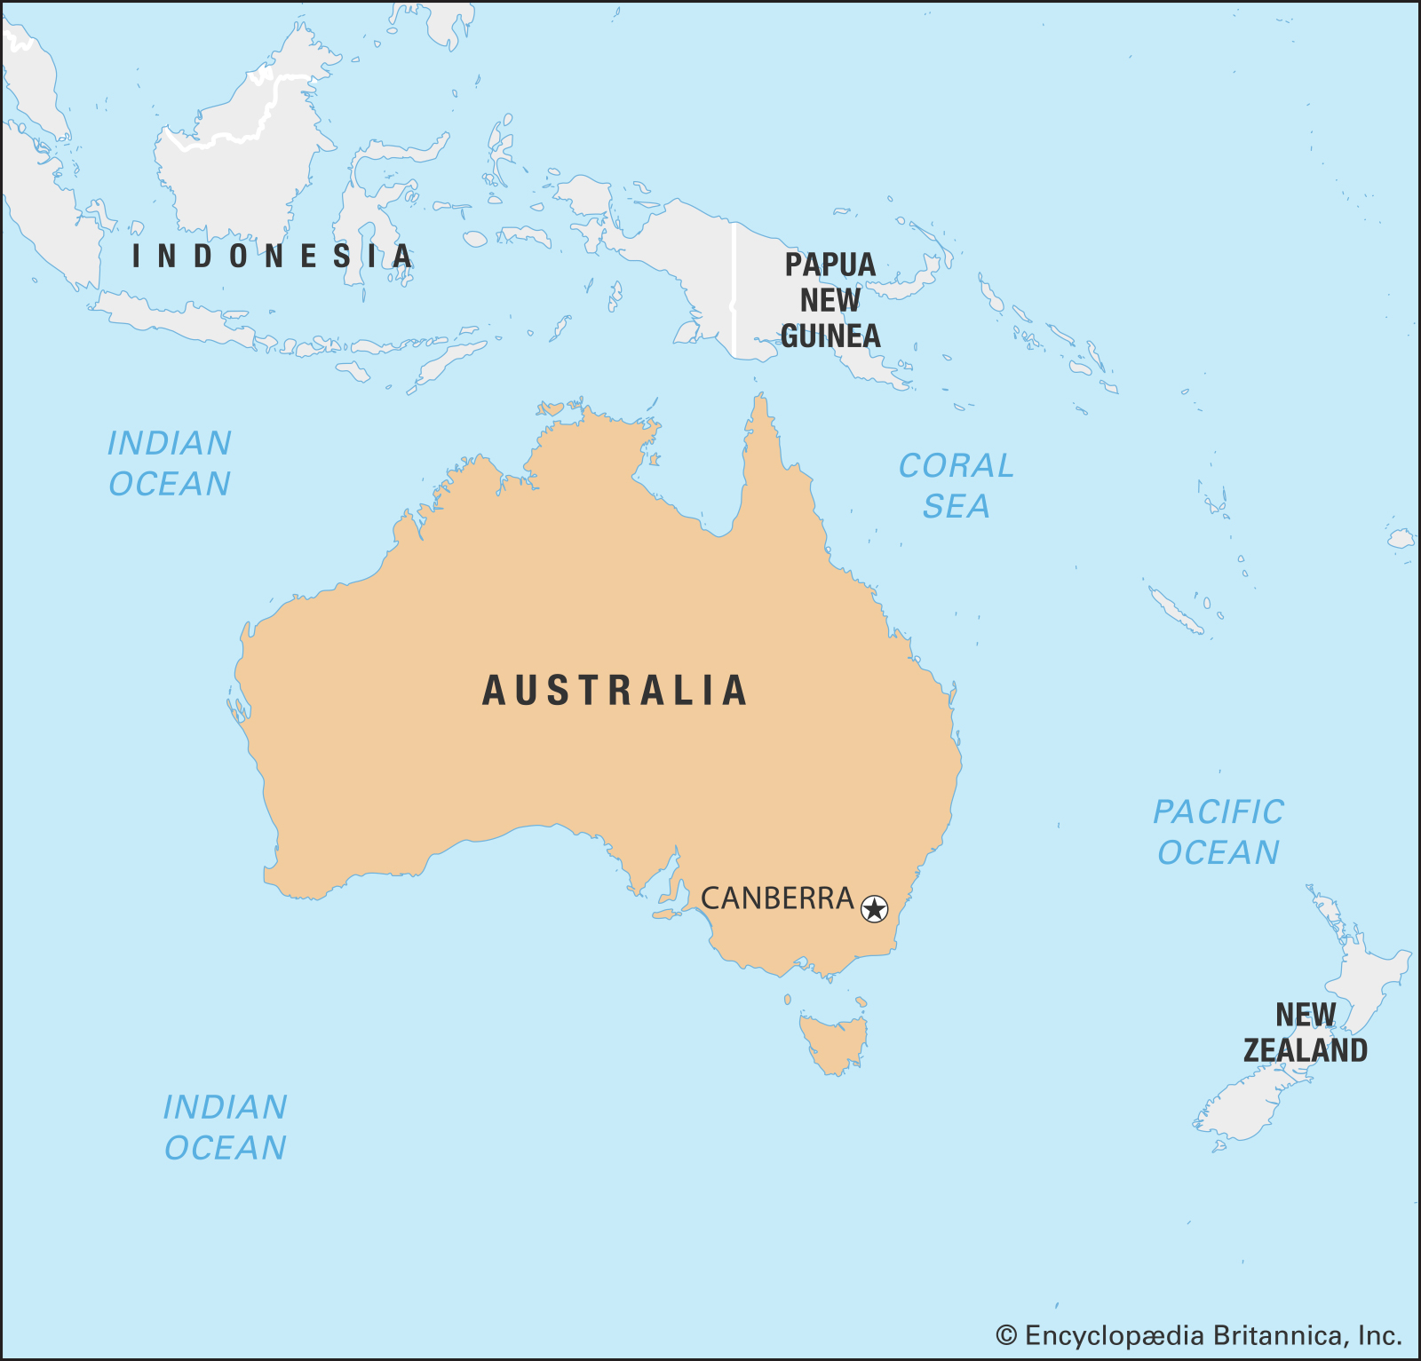

Nathan Donoso
Ms. Borgiel
BBB 4M1
Friday, October 30th, 2020
Candy Planet Expanding To Australia
Candy Planet is looking towards a new future, Candy Planet is expanding to Australia. I have been tasked to take on the job of developing a business plan for a new line of candy/chocolate. This new product that I have come up with will blow up in the Australian market. I have created something that has a twist on both ends, making it suitable for almost anyone liking candy or chocolate. This product is called “Bonzers Balls” and these little treats are tinny pebble like candies that are maybe the size of a dime in width. They are colourful candy covered chocolate pebbles. They are a prefect sphere and yes, they are very tasty and a lovely movie eating snack. The exquisite, sweet taste of the delicious candy and when you just think you are done, chew the rest and you enter the creamy milk chocolate, ready for your delight. This product is quite affordable to produce, and the profit margin between production and retail/wholesale cost is very good. This goodie is geared towards mostly any country, but I do believe that a product like this would really do the trick in Australia because after doing some research, you will realize that the ratio between candy lovers and chocolate lovers are about the same, so why not add them together.
Australia is a continent and an island located in Oceania between the Indian Ocean and the South Pacific Ocean. It shares its name with the country that claims control over it. Properly called the Commonwealth of Australia, its territory consists of the entire continent and smaller outlying islands. This makes it the sixth largest country in the world by area of jurisdiction, which comprises 7,686,850 square kilometres, which is slightly smaller than the United States and 31.5 times larger than United Kingdom. Australia also has the largest area of ocean jurisdiction of any country on earth. Australia uses three main time zones: Australian Western Standard Time, Australian Central Standard Time, and Australian Eastern Standard Time. The most popular out of the three is Australia Easter Standard Time. This time zone is in use in the eastern portion of Australia, some big cities in this time zone include Brisbane and Sydney. In summer (December-February) the average temperatures range between 20°C and 35°C. In winter (June-August) the average temperature range is 3°C to 20°C. Spring and autumn have warm days and cool evenings. Rainfall in Australia varies dramatically from year to year, but the annual average is around 286mm.
Australia’s existing infrastructure currently is stunning. The pictures definitely do not do enough. If you do one day go to Australia you will see how beautiful and stunning the cities are. There are great roads, waterways, ports, airports, and more. They have lovely beaches, historical artifacts, great food, and most importantly the kangaroos. Road infrastructure in Australia is generally very good. Both urban and inter-city roads are well developed across the country. “The quality of infrastructure services is high for most Australians in urban areas; however, population growth is impacting some services.” Quoted by Infrastructure Australia.
The demography of Australia covers basic statistics, most populated cities, ethnicity and religion. The population of Australia is estimated to be 25,689,000 as of 30 October 2020. Australia is the 52nd most popular country in the world and the most popular Oceanian country. Its population is concentrated mainly in urban areas and is expected to exceed 28 million by 2030. Sydney is ranked number one for the most populated cities. Sydney is an urban place, with lots of shop, the famous Sydney Opera House and so much more.
Like most developed countries, Australia's population is ageing as a result of sustained low fertility and increasing life expectancy. This has resulted in proportionally fewer children (under 15 years of age) in the population and a larger proportion of people aged 65 and over. In 2019, around 19.28 percent of Australia's population was between 0 and 14 years old, 64.8 percent was between 15 and 64 and 15.92 percent was 65 years old and over.
Religion in Australia is diverse. In an optional question on the 2016 Census, 52.2% of the Australian population declared some variety of Christianity. Historically the percentage was far higher; now, the religious landscape of Australia is changing and diversifying. In 2016, 30.1% of Australians stated, "no religion" and a further 9.6% chose not to answer the question. Other faiths include Muslims (2.6%), Buddhists (2.4%), Hindus (1.9%), Sikhs (0.5%), and Jews (0.4%).
Languages spoken in Australia vary as well, to start off 76.8% of people speak English, 18.2% of the population are non-English speakers. Apart from English, Mandarin is the dominant language spoken at home by 1.6% (336,178 people) speakers. Other emerging languages include Punjabi, Filipino/Tagalog, and Arabic.
The culture of Australia is a Western culture derived primarily from Britain but also influenced by the unique geography of the Australian continent, the diverse input of Aboriginal, Torres Strait Islander and other Oceanian people. The British colonization of Australia began in 1788, and waves of multi-ethnic migration followed. Australian chefs are known worldwide for their "fusion cuisine," a blending of European cooking traditions with Asian flavors and products. Nevertheless, certain foods are recognized as national emblems, including Vegemite (a yeast extract spread), Milo (a powdered base for chocolate milk drinks), Anzac biscuits (oat biscuits sent to soldiers in World War I), and damper (a wheat flour-based loaf traditionally cooked in the ashes of a fire by settlers). Most of there traditions are generic to most western countries, they celebrate Christmas, New Years, Halloween and Easter like USA, Canada and other countries similar.
The economy of Australia is a highly developed mixed economy. Its GDP was estimated at A$1.89 trillion as of 2019. In 2018 Australia became the country with the largest median wealth per adult, Australia’s national currency is Australian dollars (AUD), which comes in denominations of $5, $10, $20, $50, and $100 notes. Coins come in 5, 10, 20 and 50 cent and one and two dollar denominations. Australia’s dollar tumbled to a 17-year low on March 19 amid fears of a global coronavirus pandemic, which has since been declared by the World Health Organisation (WHO). But the Australian Dollar fell way before the pandemic had started. In the last year or so, the Australian dollar has gained some beatings from major world currencies like the US dollar. The fall began after the governor of the Reserve Bank of Australia (RBA) Philip Lowe gave a speech conceding that the Australian economy had been weaker than expected in 2018 and that rate cuts may be needed in 2019. At the time, the American Dollar was trading at 70.19 cents before dipping below that. It has never really been the same since. In 2019, the inflation rate in Australia was around 1.6%, a rate that is expected to decrease to 1.4% in 2020 and increase again to pre-pandemic levels of 1.8% in 2021, according to the latest World Economic Outlook of the IMF. This information can tell us things about Australia, how in 2019 was at a high, and was expected to decrease in 2020. This also shows the outlook for 2021 explaining how prosperous the year will be.
There are three main parties represented in the House of Representatives, the Australian Labor Party, the Liberal Party of Australia, and the Nationals. The Labor Party is Australia's oldest political party, established federally in 1901. The Australian government structure is also referred to as the Commonwealth Government. Like many other Westminster-style systems of government, the Australian Government is made up of three branches: the prime minister, the ministers, and government departments, the legislative (the Parliament of Australia), and the judicial. Australia’s latest value from 2019 is 1.09 points in Political Stability. The index is an average of several other indexes from the “Economist Intelligence Unit”, “the World Economic Forum”, and the “Political Risk Services”, among others.
Australia is known for there “well-developed” employment system, it is designed to provide flexibility and certainty to both employees and employers. All employees in Australia are entitled by law to the terms and conditions defined by national employment standards. These standards cover entitlements such as weekly working hours, requests for flexible working arrangements, leave and related entitlements, and termination and redundancy payments. The national minimum wage is $753.80 per week, for a 38 hour week. If you looked at it hourly, you would approximately be making $19.84/hour. For teenagers looking to get a job, it is really shocking that the minimum wage for a 16 year old is $11.79 and for a 17 year old its approximately $14.15 per hour. While a 37.5 hour work week is the normal in industry awards and agreements (Unions etc.), most employed Australians usually work shorter or longer hours. Only a minority of Australians actually report working 37.5 hours per week. On May 2016, the average weekly hours of work (that is, not including overtime) for full-time adult employees on award rates of pay was 37.4 hours. This number does then rise to around 37.8 hours for those on enterprise agreements, and to 38.5 for those whose pay is determined by individual agreements (running own shop/business).
Australia's main export is iron ore, followed by their other most valuables exports coal, gold, and petroleum. These exports alone gather up to $48.2 billion, $47 billion, $29.1 billion, and $20.3 billion, respectively. Australia also ships other noteworthy items including food, wine, and cars. Australia also has strong trade ties with the rest of the world. The geographical location of Australia has also allowed Australia to become a major supplier to markets in the Asia-Pacific region. The Australian Government has a number of policies that seek to develop and assist Australian businesses involved in international trade. Australia has six Free Trade Agreements with other countries in force and another eight under negotiation. The FTAs contain commitments by each member to restrict access to their markets for goods and services as well as investments.
Australia is a big country with many parts involved. Look at it in this way, there are four modes of transportation available in Australia to this date: maritime (aquatics/boats), aviation (plane), rail and road (transport trucks). Each mode of transportation has its own set of benefits and drawbacks, and freight brokers consider factors like the distance, capacity, duration, fuel cost and the topography prior to selecting a preferred mode of transportation. On top of everything all freight brokers consider the cost of the procedure, based on what clients want and are looking for. For example the price may be costly if your transporting to rural areas by rail. There is a plenty of factors which add up to the total cost of different modes of transportation. Consider the fuel cost, labour cost, accident and insurance, regulatory fees, maintenance, and etc. A recent study on transportation has actually found out the fact that the Australian rail transportation charges the highest average fee for transportation. the fuel efficiency of road transportation is quite low compared to other modes of transportation like maritime and rail transporting. These conditions are all under minimalistic studies (lowest weight, etc.). Australia’s maritime shipping provides the best benefits even though it consumes quite a bit of time compared to road and rail transportation. Finally, road transportation done through large trucks and rental vans holds great risk when it comes to thefts and accidents. This encourages people to pick using the water and rail transportation over road transportation. But if you are looking to ship a short distance, road transportation is the most convenient and easiest mode of transportation.
From all this information and research provided, with confidence there are many ways Candy Planet can dodge the risky business and the painful hurdles.

